**Activity: 06**

**Name: Muhammad: Laraib Akhtar**

**Section: BCS-1B**

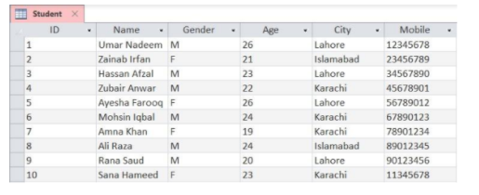

1. **Display (select) all students who live in Karachi**

select *

from Student

where City=”Karachi”

1. **Display all female students who live in Lahore or Islamabad**

select *

from Student

where City=”Lahore” OR City=”Islamabad”

1. **Display all female students who are younger than 24 years and live in Karachi**

select *

from Student

where Age<24 AND City=”Karachi”

**4. Insert a new student with the following data:**

**a. Name: Hira Jamil Gender: F Age: 25 City: Lahore Mobile: 22456789**

insert into Student

values (“Hira Jamil”, ‘F’, 25, “Lahore”, 22456789)

**5. Insert a new student in the table with the following data:**

**a. Name: Ali Amin Gender: M Age: 21 City: Karachi Mobile: 33567890**

insert into Student

values (“Ali Amin”, ‘M’, 21, “Karachi”, 33567890)

**6. Display all male students who are younger than 23 years and live in Karachi**

select *

from Student

where Gender=’M’ AND Age<23 AND City=”Karachi”

**7. Update the age of student with ID 9 from 20 to 21**

update Student

set ID=9

where Age=21 OR Age=20

**8. For student with ID 2, update city to Karachi and mobile number to 44678901**

update Student

set City=”Karachi”, Mobile=44678901

where ID=2

**9. Delete all male students who are older than 23 years**

delete from Student

where Age>23